Que3

Write a program to create a class named shape. In this class we have three sub classes circle, triangle and square, each class has two member function named draw () athese using Runtime

Polymorphism concepts. (10 MarksQue3

Que3 Write a program to create a class named shape. In this class we have three sub classes circle, triangle and square, each class has two member function named draw () athese using Runtime 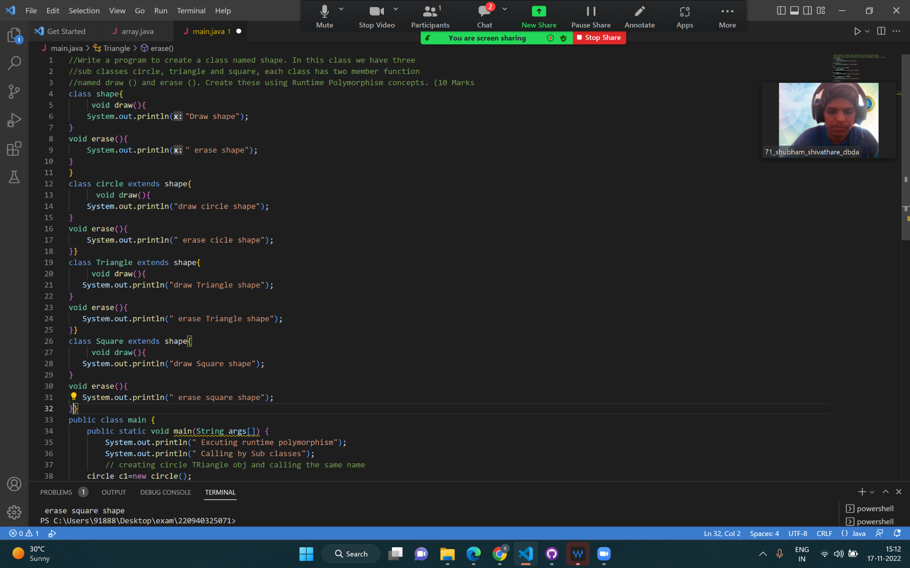

Output que3

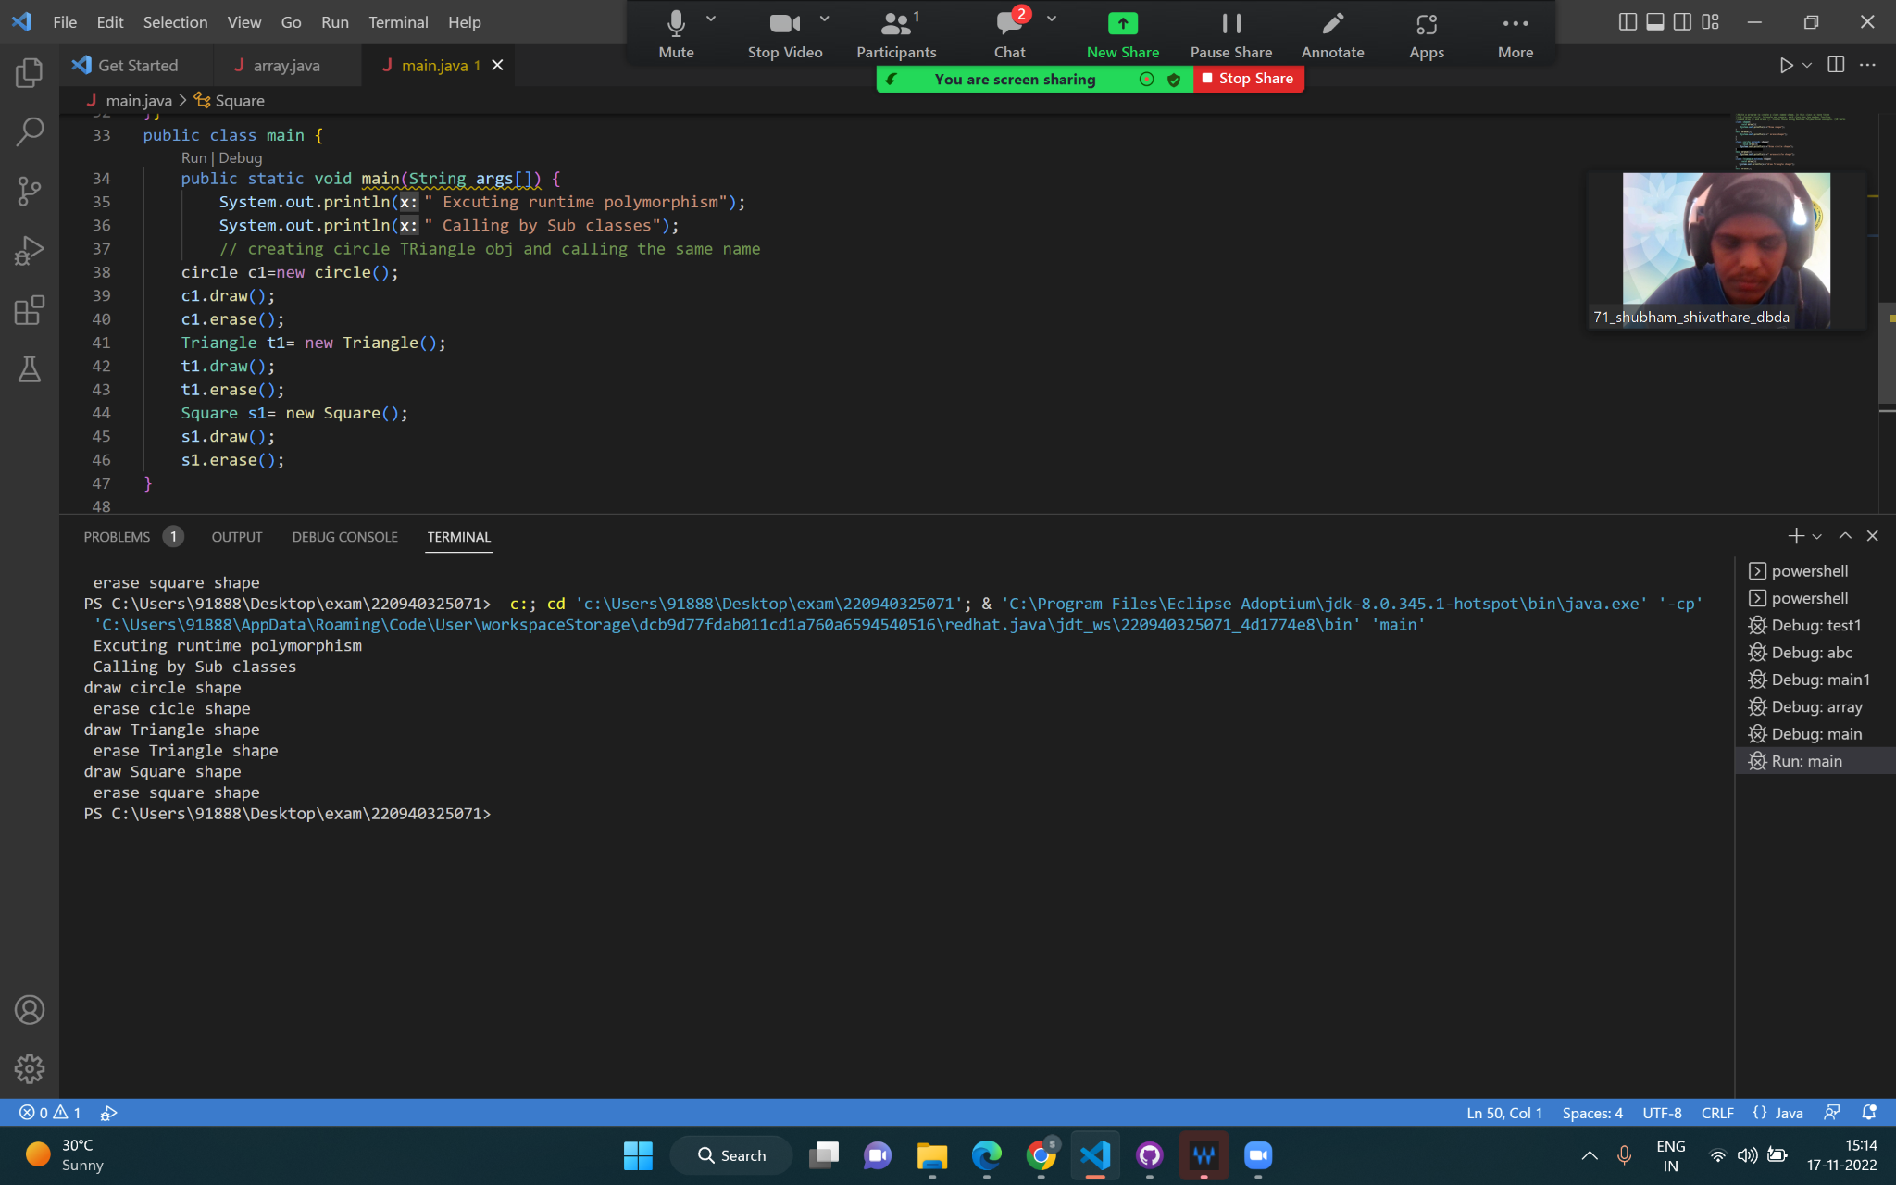

Output of que3

Que.4

Constructor chaining

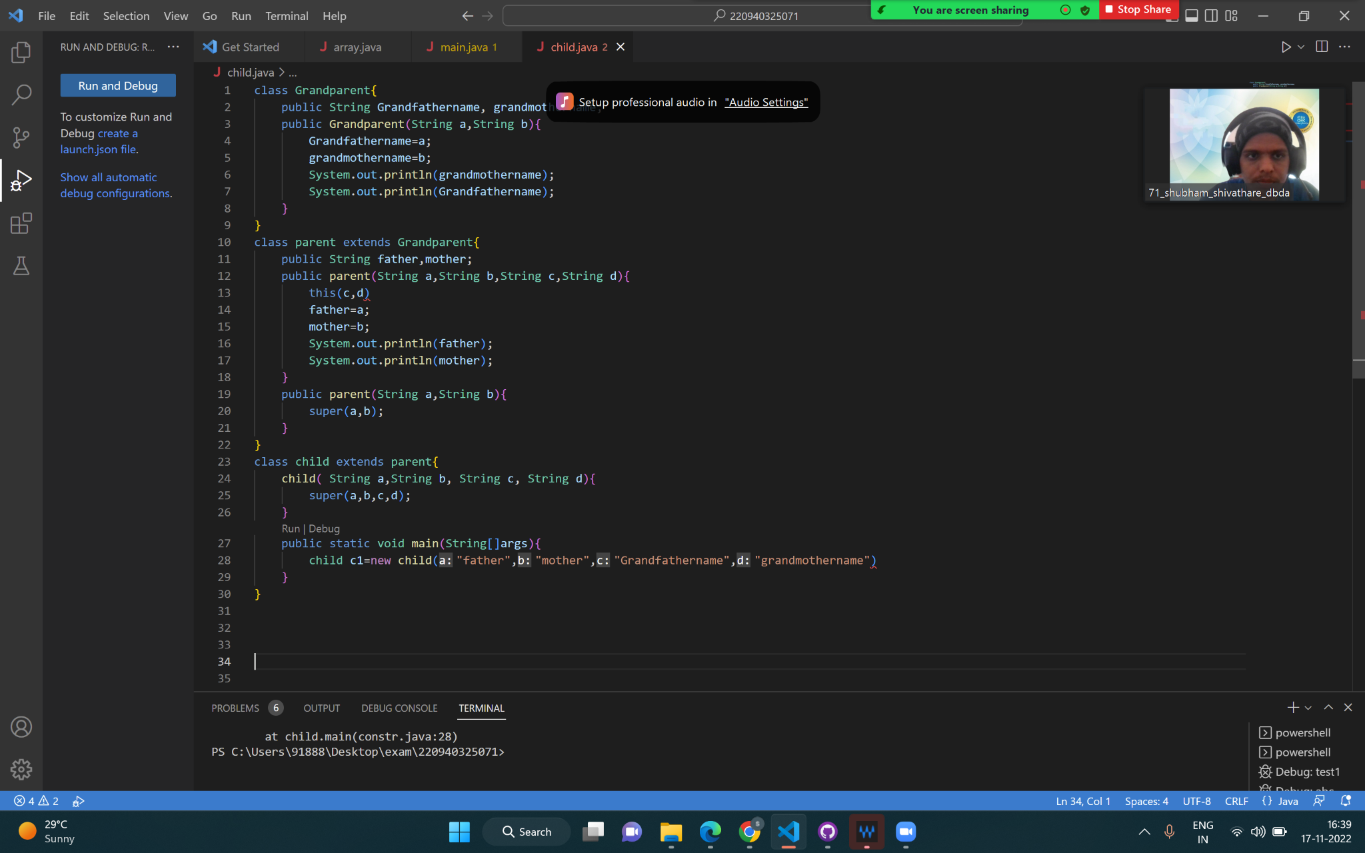

Output of que4

